JURATE SELANDER  GLOBAL MARKETING & COMMUNICATIONS  Life Science • Product Marketing • International Growth  Gothenburg, Sweden • [phone] • [email]  linkedin.com/in/jurate-selander-71a39113a | 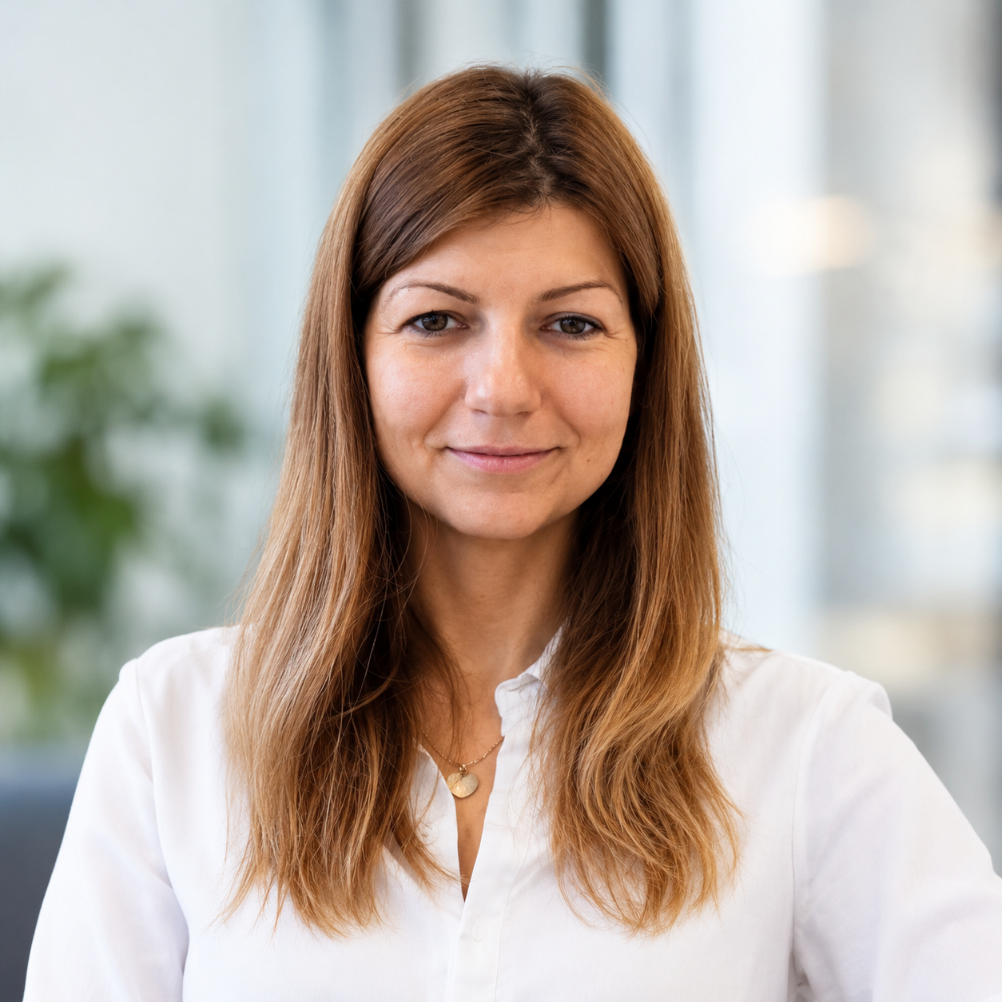

PROFILE
Strategic and hands-on global marketing communications professional with 9+ years of experience in Life Science and scientific instrumentation. Skilled at translating complex product and application information into clear positioning, commercially relevant campaigns and practical sales support. Brings end-to-end experience across product launches, portfolio communication, brand development, distributor enablement, expert-led education and digital growth. Known for creating clarity, building alignment across functions and turning strategy into high-quality execution for international markets.

CORE VALUE
PRODUCT & COMMERCIAL positioning, portfolio communication, launches and sales enablement
GLOBAL ACTIVATION distributor marketing, cross-market campaigns and consistent messaging
SCIENCE TO STORY expert-led education, KOL content and clear customer-value communication
DIGITAL GROWTH HubSpot CRM, demand generation, analytics, SEO, GEO/AEO and AI implementation

PROFESSIONAL EXPERIENCE
Communication and Inbound Marketing Manager | Biolin Scientific AB
Sep 2022 – Present | Gothenburg, Sweden
- Global portfolio: Own global marketing communications for QSense, Attension and KSV NIMA—three scientific-instrumentation brands serving research and industry worldwide.
- Positioning: Translate technical and application knowledge into clear customer-value messaging for international customers, sales teams and distribution partners.
- Product launches: Lead end-to-end launches and portfolio campaigns—from go-to-market planning and messaging to sales materials, distributor toolkits, digital activation and optimization.
- Cross-functional leadership: Partner with sales, product management, application scientists, R&D and external experts to turn customer and market insight into relevant campaigns and education.
- Education & engagement: Create expert-led webinars, application content, customer stories, workshops and digital learning resources that build trust and commercial opportunity.
- Sales & distributors: Equip sales teams and distributors with clear priorities, launch plans and adaptable assets, supporting consistent messaging and effective local execution.
- Digital performance: Develop the inbound engine through HubSpot CRM, websites, email automation, social media, video, SEO and emerging GEO/AEO practices; contributed to a 25%+ increase in leads.
- Ownership & improvement: Introduce responsible AI-supported workflows, establish project priorities and present strategies, KPIs and recommendations to senior management and the CEO.
Marketing Specialist | Biolin Scientific AB
Apr 2017 – Aug 2022 | Gothenburg, Sweden
- Delivered multi-channel campaigns, product communication, sales materials, landing pages, email programs and educational content for global Life Science and materials-science audiences.
- Built hands-on expertise in HubSpot, websites, SEO, paid and organic digital channels, lead generation, analytics and campaign improvement.
- Produced expert webinars, customer stories, application content, video and event communication while helping evolve the company’s brand and commercial messaging.

EARLIER EXPERIENCE
Freelance Marketer | Independent
[add dates]
- Supported clients with practical marketing communication, content and digital activities, adapting quickly to different audiences, priorities and brand contexts.
PR / Digital Marketing | Utrikespolitiska Föreningen Göteborg
2015 – 2016 | Gothenburg, Sweden
- Supported public relations and digital communication for a member-led organization, promoting activities and strengthening audience engagement across communication channels.

SELECTED MARKETING CAPABILITIES
Strategy & leadership: Global marketing planning, product positioning, go-to-market strategy, budget prioritization, team and project coordination, KPI frameworks and executive presentations.
Product & commercial marketing: Portfolio communication, product launches, customer-value messaging, sales materials, campaign development and close collaboration with sales, distributors and technical teams.
Education & engagement: Expert- and KOL-led webinars, application content, customer stories, workshops, digital learning resources, video and event communication.
Growth & digital: Inbound marketing, lead generation, conversion journeys, campaign optimization, websites, CRM, email automation, SEO, GEO, AEO, paid media and organic social.
Global activation: Distributor enablement, partner toolkits, international campaign coordination, message consistency, sales collaboration and adaptable multi-market execution.
AI-enabled marketing: AI-assisted research and analysis, content operations, workflow improvement, AI-search readiness, responsible governance and human expert review.

TOOLS & PLATFORMS
HubSpot CRM & Marketing Hub • GA4 • Google Search Console • Google Ads • LinkedIn Campaign Manager • CMS/website publishing • Microsoft 365 • Webinar and video platforms • AI productivity and content tools

EDUCATION
Aarhus University | [degree, field of study and dates]

LANGUAGES
Lithuanian • English • Swedish

ADDITIONAL VALUE
- Combines long-term strategic thinking with hands-on delivery—from the first positioning discussion to published assets, sales activation, measurement and improvement.
- Experienced in a purpose-led Life Science environment where clear communication, scientific credibility and commercial impact must reinforce one another.
- Creates structure and momentum across complex projects through clear priorities, collaborative working relationships, ownership and calm execution.
- International outlook with experience supporting global brands, local markets, direct sales teams, technical experts and external distribution partners.

